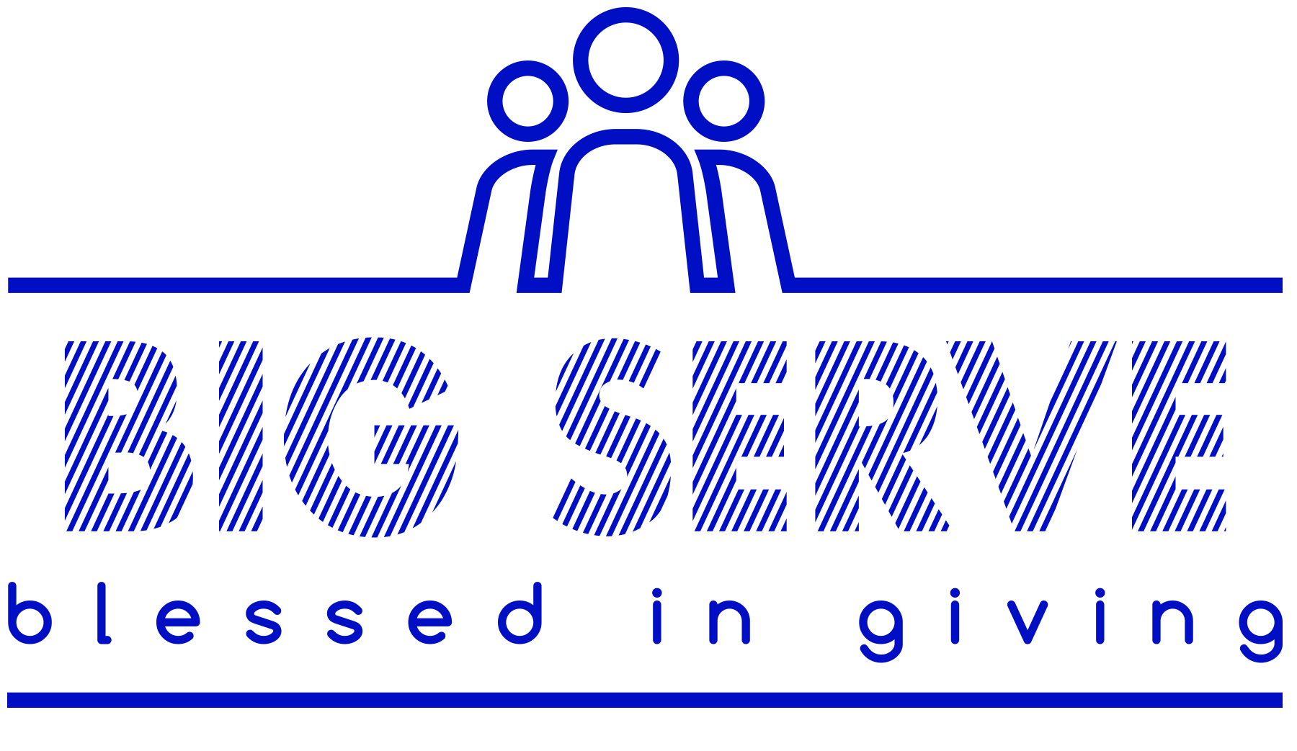

Dallas Thunder - BIG Serve - November 4th, 2017

Dear Family/Friend ,
We are reaching out to you asking for support for our organization as a sponsor for the Dallas Thunder. Dallas Thunder was founded in April of 2003 by 5 families in search of an atmosphere of quality and excellence for our young athletes. Since that time, the organization has grown and excelled on and off the court, fielding boys’ and girls’ teams at every age level (10u-18u) in most years, developing a reputation as a strong “Thunder family”, and even competing for titles at a state and national level!

Thunder is a 501c3 non-profit organization providing high quality basketball training for Homeschool students. Our students use the program as their schools sports and physical education program. Our head coaches are paid a stipend and give of their time and pour into these players with over 130+ hours over the season developing both basketball skills and character. Our 10 teams practice at PSA in Murphy Texas and play games all over the Dallas Fort-Worth metroplex.

On November 4th, we will have the opportunity with more than 150 people from Dallas Thunder– players, parents, and coaches—and take part in the 3rd Annual Dallas Thunder BIG Serve! As we serve, I know we will be Blessed In Giving to our neighbors. We will work with City of Murphy, Read Play Love, Hope's Door, Oxford Glenn Memory Care, and Life Message (food bank) to serve these organizations and the people that they serve. We believe that our high calling is to serve our neighbors in love and so our organization will reach out to our community this fall with an organization-wide service project designed to make a difference in our community.

We are seeking sponsorships from family members and friends, and the funds collected through these sponsorships will be used to support these service projects and the ongoing growth of our organization. I am privileged to take part in the BIG Serve, and your sponsorship will help make my service possible.

Would you be willing to sponsor me for $50-$500, or for whatever amount you are able? Thank you in advance for your consideration and generosity. Any amount you are about to donate is greatly appreciated by all those who are connected to Dallas Thunder! If I don’t hear from you within a week I hope you won’t mind if I give you a follow up phone call just to see if you have received this letter.

Sincerely,

Note: All contributions are tax-deductible and a statement will be sent January 2018.

Make checks payable to DHB (Dallas Homeschool Basketball) (note please put Thunder player name)
Paypal payments can be sent through Friends/Family section to payment@dallasthunder.org (notes section please put Big Serve and the Thunder player name)

http://dallasthunder.org/big-serve.html

YES! I agree to sponsor in the 3rd Annual Dallas Thunder BIG Serve!

Contact name:

Email:

Phone number:

Name of Thunder Player:

Donation Amount:

Please send me a tax donation form:

_____ Yes

_____ No

